GOALS STOCKTON SUNDAY LEAGUE

**(Founded 1968)**



  

**President: Mr D Overton Chairman: Mr P Mack Treasurer: Mrs J Johnson**

**Secretary: Ken Clark Mobile: 07504 303153** Website: [www.stocktonsundayleague.org.uk](http://www.stocktonsundayleague.org.uk)

28 Leicester Road, Norton, Stockton on Tees TS20 2RB Email: [Ken.Clark@Stocktonsundayleague.org.uk](mailto:Ken.Clark@Stocktonsundayleague.org.uk)

F.A & Durham County F.A Charter Standard League

**MINUTES OF MEETING 28 September 2016**

**Held at Elm Tree Social Club**

Present: Peter Mack (Chairman), P Livingstone (Vice Chairman),D Overton, L Golightly, M Blackburn, M Sowerby, J Lambert, G Hewitson, Jean Johnson, P Irish,

K D Clark (Secretary)

Apologies: Geoff Mann, Alan Close

The Chairman opened the meeting at 7-30, he welcomed all to the meeting then handed over to the League Secretary who advised that before the business started properly the league was to present SNAPS with the money raised as a result of presentation night. The nominated charity was SNAPS and this was proposed to the Management Committee by Mark Aithwaite the Secretary of The George Pub & Grill. Ruth Benson from SNAPS addressed the meeting and explained what they did and how the money would be used. Chairman Peter Mack then presented Ruth with a cheque for £850 and she thanked all the Clubs for the donation.

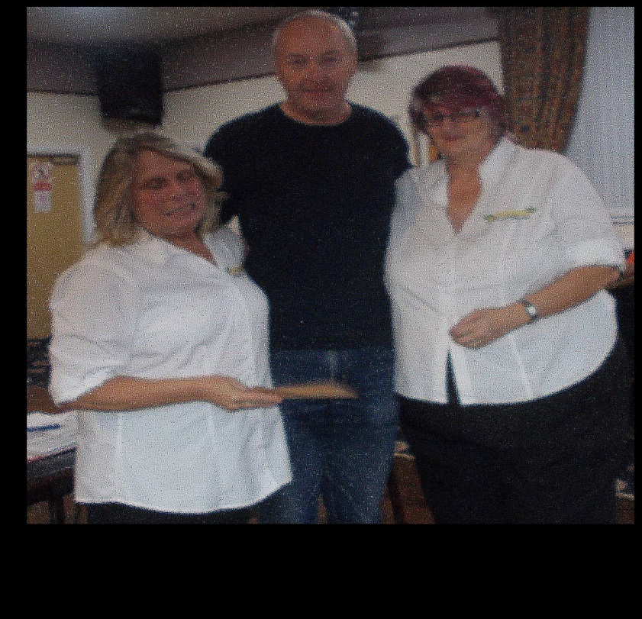

Following the presentation the minutes of last meeting’s (24 August 2016) had been posted on the website and the members agreed a true record.

##### Secretaries Report & Correspondence

Secretaries Report – Matters Arising

There are a couple of items but I have included these in the main report

**Charter Standard**

I have yet to organise a First Aid course for this season, however I am reluctant to do this as Teams are not providing the information I have asked for. At the last meeting I ask all Teams can you advise me of your first aider and the expiry date of their certificate as it only lasts three years. Failure to comply with this instruction will result in a fine being issued. As I went on holiday following the last meeting no fines have been issued so I will give teams one more chance to provide the information.

Correspondence

League Statement – from FA received on a weekly basis.

Various E-Mails requesting fixture postponements already

Emails re DFA & NRCFA County Cup games

Secretaries Report

I have to start tonight’s report with two complaints I received from the Council whilst I was away with regards to litter left by the side of pitches, this involved Tilery and Yarm Road pitch. As I have stated on many occasions we have a big problem with Yarm Road and therefore both teams who play there need to make sure all is tidy and the gate is locked. However I must add that I received a compliment this week re Yarm Road pitch from the Council as they inspect this every week and I sent an email to The Oxbridge regarding this. I have brought some bags to the meeting tonight if you require any then please take some, they are on a roll and for those teams who have changing rooms the rubbish can be left inside and the Council will collect.

For those teams who play on a Council pitch there is an invoice in your envelope tonight for the first half year payment, this is due on or before the next meeting 26 October 2016.

A reminder to Teams playing in County Cups etc to text in result of game to League Secretary within the required timescale and also advise the County FA.

Also to advise ALL teams that extra time is still played in all cups within the league and that the referee’s fee is shared between the two teams.

Teams are not following the correct process for registering players on a match day, so to remind teams of the correct process, you must complete a player registration form and this has to be countersigned by the Secretary of your opponents, if Secretary not available should be signed by a member of the team. The details, name, date of birth and address including post code then need to be sent via text to nominated league official. The player is then registered on the League website when completing their match return (do not register before the game). The completed registration form then needs to be sent or delivered to the nominated league official by 6 pm on a Tuesday along with the correct fee. If any part of this is not done correctly then a fine may be issued for incorrect process.

There is a change to the registration process in that as of tonight Jes Lambert will take over the role of Registration Secretary therefore all registrations will now go through Jes and not the League Secretary.

Just to clarify why you don’t register a player prior to match day (unless paperwork is submitted prior to game) if you do when you come to do your match return the player will not be available to select therefore for match day signings you register when doing match return that way the player will be available to select but will not be fully registered until the registration form has been received and checked by nominated league official (normally Jes Lambert).

When a mark of 55 or less is awarded then you are required to submit a report detailing why you have awarded the mark you have given, some teams have not been doing this and I have emailed them asking for a report, I should not have to do this. It is quite simple to do on the website, go to the Information tab then select Online Forms followed by Club Secretaries then Match & Referee Report then complete the report. You need to enter something in the Match Report box otherwise it will not send, just add the result here and the report is sent to Jes Lambert and myself. You can also use this to send in a match report of your game.

The FA has launched the 2016 Grassroots Football Survey, which will run from Monday 19 September until Friday 28 October, it can be accessed via the Durham County Football Association or North Riding County Football Association websites.

Once again I will put these notes on the website so you can check out anything you have missed or to use as a reminder.

**Team of the Month – August 2016**

The George Pub & Grill F.C after finishing bottom last season started with 3 wins from 3 played 13 goals for and 3 against.

**Cup Draws –** Ian Gorman Memorial Trophy Round Two & John Jackson Round One & Two draws were carried out

Date of the next League Meeting which is the General Meeting on Wednesday 26 October 2016. When both Durham County Football Association & North Riding County Football Association will be in attendance.

**Referees:**  Jes Lambert / Geoff Mann - Nothing to report

Any Other Business

League Secretary advised that Middlesbrough’s game on 16 October has been moved to Sunday 1-30 kick off, teams can kick off early or have to put 14 days’ notice in as per league rules.

The Roll Call was taken and 4 Teams were missing: Riverside F.C, Eaglescliffe F.C, Portrack F.C and The Oxbridge F.C

There being no further business the Chairman wished all best wishes for the coming season and he closed the meeting at 20-05.

Signed: ………………………………………………….. Date: 26 October 2016