GOALS STOCKTON SUNDAY LEAGUE

**(Founded 1968)**



  

**President: Mr D Overton Chairman: Mr P Mack Treasurer: Mrs J Johnson**

**Secretary: Ken Clark Mobile: 07504 303153** Website: [www.stocktonsundayleague.org.uk](http://www.stocktonsundayleague.org.uk)

28 Leicester Road, Norton, Stockton on Tees TS20 2RB Email: [Ken.Clark@Stocktonsundayleague.org.uk](mailto:Ken.Clark@Stocktonsundayleague.org.uk)

F.A & Durham County F.A Charter Standard League

**MINUTES OF MEETING 23 September 2015**

**Held at Elm Tree Social Club**

Present: P Mack (Chairman), M Sowerby, P Irish, D Overton, J Lambert, Jean Johnson,

L Golightly, P Livingstone (Vice Chairman), K D Clark (Secretary)

Apologies: J K Johnson, A Close, G Hewitson, G Mann (Referee Rep),

The Chairman Peter Mack opened the meeting at 7-33 and welcomed all to the meeting, he then handed over to Jes Lambert who introduced Mike McGrother (better known as the lead singer of the Wildcats of Kilkenny) who was accompanied by Matty Brown. Jes asked Mike to outline where the money they would be presented with would go towards, Mike explained they worked with local community to improve things for the people of Stockton on Tees, especially young people with mental health problems and other vulnerable groups. Mike explained about projects they had helped to organise providing work experience for young people and explained the money raised would go towards pensioners at Christmas. The League Chairman Peter Mack then presented Mike with a cheque for £900 from money raised mainly through the presentation night.

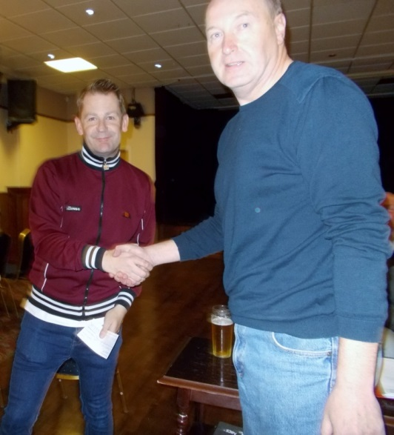

Pictured Peter Mack presenting cheque to Mike McGrother, Mike thanked the members for the donation.

The League Secretary advised the members that the minutes of the previous meeting July 2015 had been posted on the League website the members agreed with this and they were signed by the Chairman.

##### Secretaries Report & Correspondence

Secretaries Report – Matters Arising

Nothing

**Charter Standard**

First Aid course is organised for the 4 November 2015 here at Elm Tree, those teams that need to renew their First Aid or to get somebody qualified this is the time to do it. Also gives new teams a chance to get somebody qualified. I have included an application form for those teams whose certificate is due to run out also one for all the new teams.

Correspondence

League Statement – from DFA received on a weekly basis.

Various E-Mails requesting fixture postponements

Email from Stockton Rangers, Stockton Hardwick and North Ormesby Cons re resignation from league.

Secretaries Report

I am starting tonight’s report with disappointment due to the resignation of three teams from the Premier Division, it is now a major cause for concern as teams work their way up to the Premier Division and then resign, two of the teams without even kicking a ball. I don’t know what the answer is, there are plenty of teams at the bottom end of the league as shown by having 14 teams in Division Two and 12 in Division One but the Premier Division is becoming something of a bit of a joke.

I have to advise that following a League Management Committee Meeting the three teams concerned where all fined the maximum of £250, the Management Committee felt they had been totally let down by the teams concerned, all players who were registered with these teams have had a letter detailing what their share of the fine is. I have received a number of phone calls about these especially players stating they never signed a form but if that is the case somebody has forged the signature and I have advised the players concerned that they should take this up the team concerned as they have submitted the registration for the coming season. One takes it on trust that the player concerned has signed the form and that the team have submitted a form with the signature on.

A few points with regards match return; it is no good ringing up or texting advising you are having problems after the 6 pm deadline on a Tuesday. Also when awarding a referee mark of less than 55, then a report needs to be submitted via the website, failure to do will result in a fine. The report can be found on the website under Information tab then Online Forms followed by Club Secretaries then complete Match and Referee Report, this report then goes to Jes and also me.

For the Durham County Football Association Teams I have received some of the Players Insurance Invoices today, please check as I have quickly done them for the meeting and I have issued these in your envelope with the date for payment, this will be required by the date on the invoice that I have issued. One point to bear in mind is that if a player originally signed for you and has since transferred your team is still responsible for paying the Insurance. This should have previously been collected by the team with the initial signing as advised, however if the player refuses to pay then advise me and the player will be suspended until he pays, but the Club must still submit the payment.

For those teams who play on a Council pitch then the first payment is now due and an invoice is included in your envelope tonight, payment is due by 10 October to the League Secretary, failure to pay will result in Club being suspended as the League will be paying the fees so the money will be owed to the League.

I have been advised by Durham County Football Association that a number of players that have registered for this season are currently suspended and clubs advised accordingly therefore the outstanding fines need to be paid to whoever they owe the fine to.

I did send an email out re Captains armbands and all referees have been advised to report if team does not have the captain wearing the arm band this carries a mandatory fine of a maximum of £10, if you don’t have one I still have some left.

Also I am now getting complaints from teams about the state of dressing rooms that away teams are leaving them in, can I ask it is a simple matter to clean up tape and bottles before you leave, just as we ask you to do on the side-lines. Last Sunday was the first week I didn’t receive a complaint from the Council re mess on pitches, please keep this up.

The fixtures for the next round of the Durham Sunday Cup are not included as the fixtures were printed out before I got the draw; fixtures are on the website apart from Billingham The White House as opponents are unknown.

I have also included in your envelope tonight a revised points system for the Good Conduct award, the latest table is also included up to 13 September, and this week’s not added yet.

Date of the next League Meeting which is the Annual General Meeting is on Wednesday 21 October 2015.

Once again I will put these notes on the website so you can check out anything you have missed or to use as a reminder.

**Team of the Month** – August 2015 - Will be awarded next month

**Cup Draws** – The following cup draw was carried out Ian Gorman Memorial Trophy Round Two.

**Referees:**  Jes Lambert / Geoff Mann

Jes reported that referee Peter Cassidy has had to retire from officiating due to ill health.

Any Other Business

Kick off for Sunday for the Boro v Leeds match if kicking off early please let League Secretary know.

Peter Livingstone (South Bank) raised concerns over the Whole Game System, the North Riding County Football Association do not have a list of registered players for each team, the only players who are registered are those who receive a caution or are dismissed. The League Secretary reported that he has sent the North Riding County Football Association every player who has registered this season. He highlighted a player who appeared on one list of suspended players re Thornaby Meerkats but not on the list as supplied by the league.

Thornaby Aerodrome Club mentioned they don’t have a list of their players; League Secretary pointed out that teams should keep a register of their players, League Secretary to send Thornaby Aerodrome Club a list of registered players.

The Roll Call was taken and 5 team were missing, Roseworth Social, Billingham The Kings, Norton Unicorn, Norton WMC and Eaglescliffe F.C.

There being no further business the Chairman reminded members that the date of the next meeting is the 21 October 2015 and he closed the meeting at 20-00.

Signed: ………………………………………………….. Date: 21 October 2015